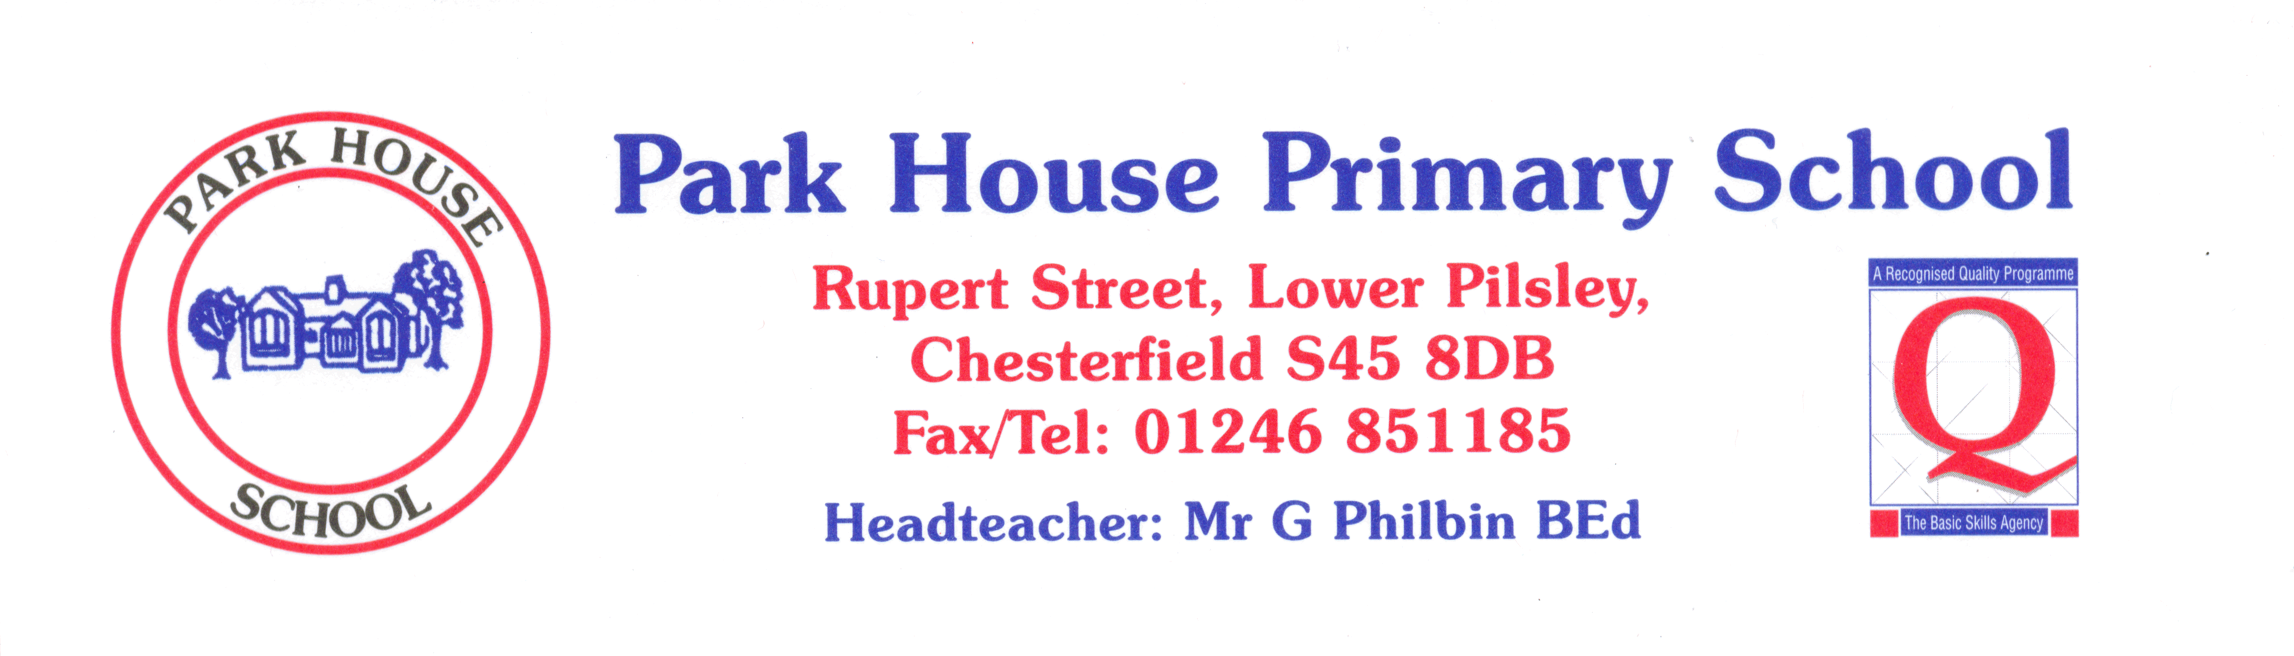

 | YEAR | Always | Nearly always | Sometimes | Never
1 | I like coming to school. | 64 | 33 | 3
2 | I learn a lot in lessons. | 54 | 43 | 3
3 | My teachers help me to do the best I can. | 87 | 13
4 | I know how well I am doing at school. | 54 | 40 | 6
5 | Adults in school explain to me how to make my work better. | 74 | 20 | 6
6 | Teaching at our school is good. | 90 | 10
7 | Teachers help me to read, write, do my number work  and talk to others. | 77 | 20 | 3
8 | Behaviour is good in school. | 34 | 63 | 3
9 | Behaviour is good in lessons. | 77 | 23
10 | The teachers sort it out if somebody is being bullied. | 91 | 3 | 6
11 | I feel safe when I am in school. | 94 | 6
12 | Teachers are interested in what I think. | 74 | 20 | 6
13 | Teachers expect me to be responsible for my work in class. | 94 | 6

