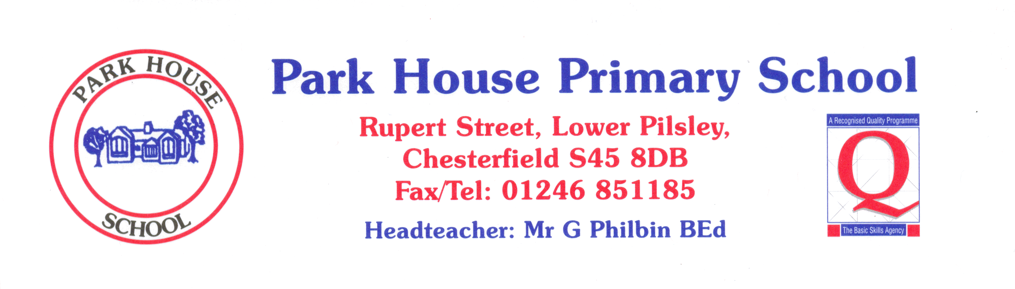

 | YEAR 4 in % | Always | Nearly always | Sometimes | Never
1 | I like coming to school. | 48 | 45 | 7
2 | I learn a lot in lessons. | 76 | 24
3 | My teachers help me to do the best I can. | 79 | 7 | 14
4 | I know how well I am doing at school. | 45 | 21 | 34
5 | Adults in school explain to me how to make my work better. | 80 | 17 | 3
6 | Teaching at our school is good. | 80 | 17 | 3
7 | Teachers help me to read, write, do my number work  and talk to others. | 82 | 10 | 7 | 3
8 | Behaviour is good in school. | 69 | 17 | 14
9 | Behaviour is good in lessons. | 55 | 38 | 7
10 | The teachers sort it out if somebody is being bullied. | 69 | 21 | 3 | 7
11 | I feel safe when I am in school. | 66 | 31 | 3
12 | Teachers are interested in what I think. | 58 | 28 | 14
13 | Teachers expect me to be responsible for my work in class. | 90 | 3 | 7

