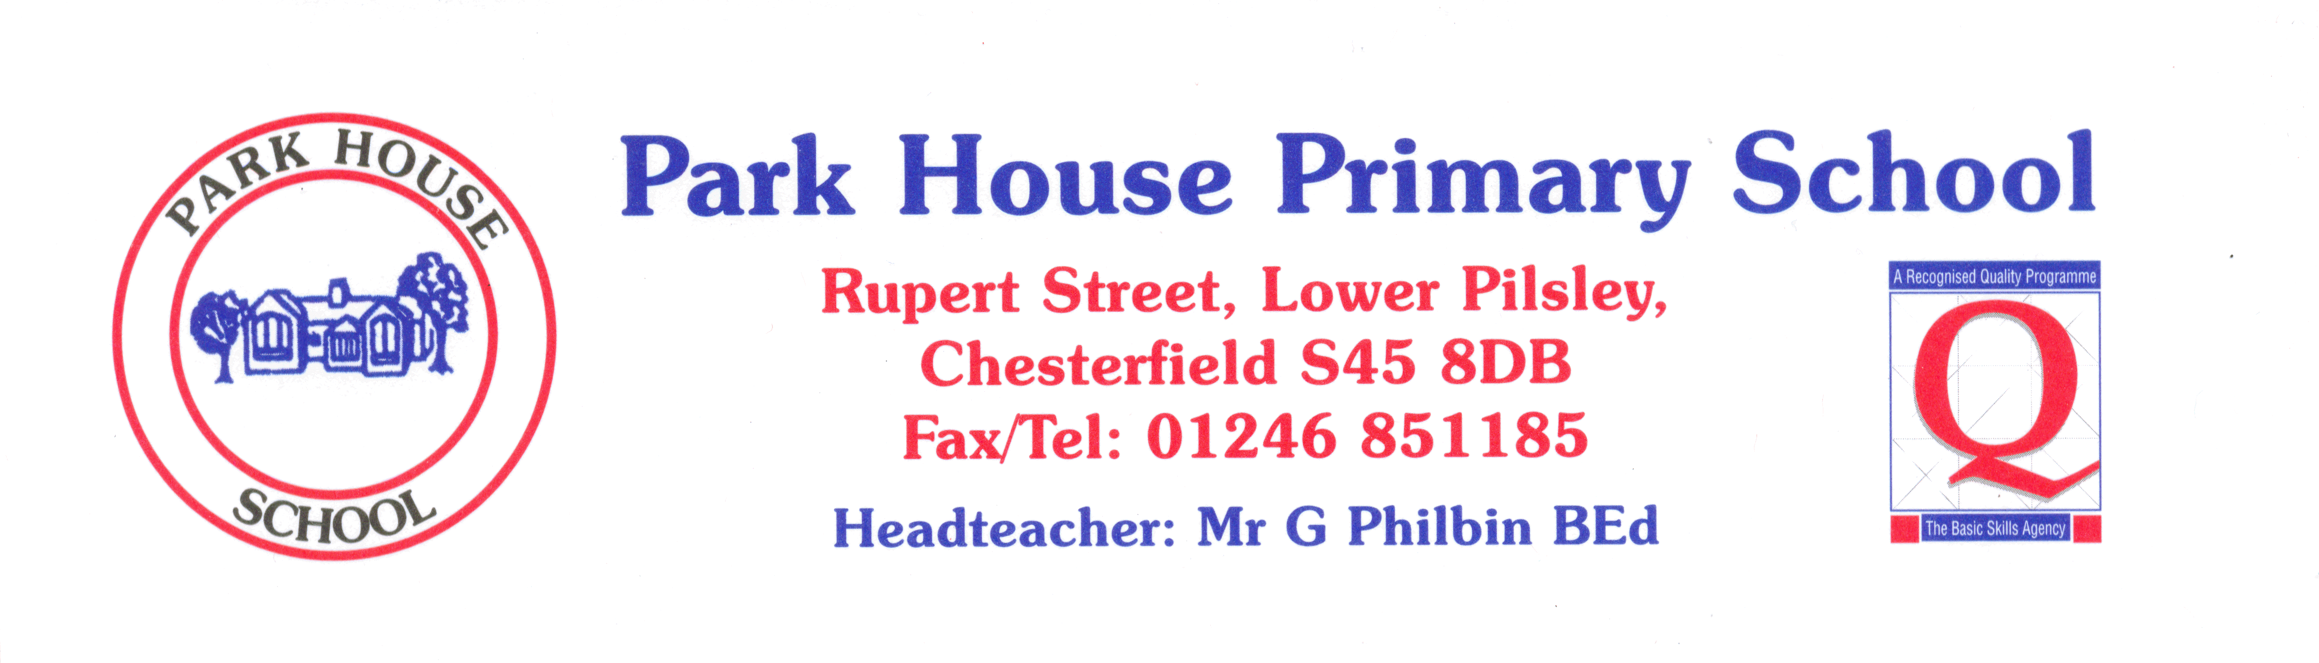

 | YEAR 3 | Always | Nearly always | Sometimes | Never
1 | I like coming to school. | 80 | 17 | 3
2 | I learn a lot in lessons. | 94 | 6
3 | My teachers help me to do the best I can. | 94 | 3 | 3
4 | I know how well I am doing at school. | 70 | 14 | 16
5 | Adults in school explain to me how to make my work better. | 84 | 13 | 3
6 | Teaching at our school is good. | 100
7 | Teachers help me to read, write, do my number work  and talk to others. | 90 | 4 | 6
8 | Behaviour is good in school. | 67 | 23 | 10
9 | Behaviour is good in lessons. | 81 | 13 | 6
10 | The teachers sort it out if somebody is being bullied. | 94 | 6
11 | I feel safe when I am in school. | 90 | 10
12 | Teachers are interested in what I think. | 88 | 6 | 6
13 | Teachers expect me to be responsible for my work in class. | 97 |  | 3

