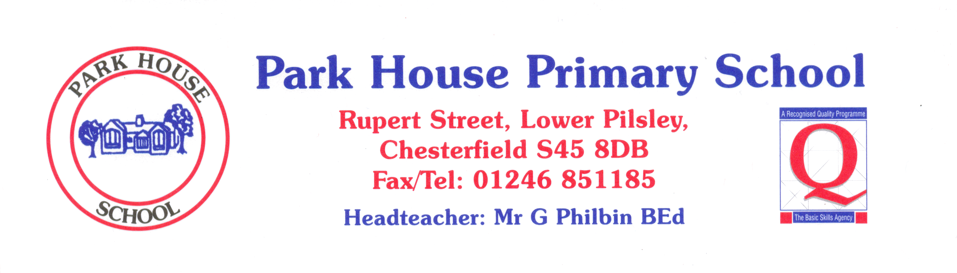

 | YEAR 1 | Always | Nearly always | Sometimes | Never
1 | I like coming to school. | 79 | 7 | 14
2 | I learn a lot in lessons. | 60 | 20 | 20
3 | My teachers help me to do the best I can. | 73 | 7 | 20
4 | I know how well I am doing at school. | 42 | 41 | 14 | 3
5 | Adults in school explain to me how to make my work better. | 72 | 14 | 14
6 | Teaching at our school is good. | 69 | 24 | 7
7 | Teachers help me to read, write, do my number work  and talk to others. | 76 | 14 | 10
8 | Behaviour is good in school. | 69 | 17 | 14
9 | Behaviour is good in lessons. | 66 | 14 | 17 | 3
10 | The teachers sort it out if somebody is being bullied. | 80 | 17 | 3
11 | I feel safe when I am in school. | 79 | 14 | 7
12 | Teachers are interested in what I think. | 70 | 24 | 3 | 3
13 | Teachers expect me to be responsible for my work in class. | 80 | 20

